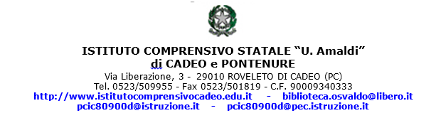

Allegato n. 1
RELAZIONE FINALE

PROF. _____________________________________________________________________

DOCENTE DI _______________________________________________________________

nelle classi: _________________________________ ore sett.li ___________________

ANNO SCOLASTICO __________ / _________

1) - Svolgimento del programma e coordinamento interdisciplinare. Criteri didattici seguiti e mete educative raggiunte.

_______________________________________________________________________________________________

_______________________________________________________________________________________________

_______________________________________________________________________________________________

_______________________________________________________________________________________________

_______________________________________________________________________________________________

_______________________________________________________________________________________________

_______________________________________________________________________________________________

_______________________________________________________________________________________________

_______________________________________________________________________________________________

_______________________________________________________________________________________________

_______________________________________________________________________________________________

_______________________________________________________________________________________________

_______________________________________________________________________________________________

_______________________________________________________________________________________________

_______________________________________________________________________________________________

2) - Profitto medio ottenuto e criteri di valutazione. Comportamento degli alunni e giudizio sul rendimento di ciascuna classe.

_______________________________________________________________________________________________

_______________________________________________________________________________________________

_______________________________________________________________________________________________

_______________________________________________________________________________________________

_______________________________________________________________________________________________

_______________________________________________________________________________________________

_______________________________________________________________________________________________

_______________________________________________________________________________________________

_______________________________________________________________________________________________

_______________________________________________________________________________________________

_______________________________________________________________________________________________

_______________________________________________________________________________________________

_______________________________________________________________________________________________

_______________________________________________________________________________________________

_______________________________________________________________________________________________

_______________________________________________________________________________________________

_______________________________________________________________________________________________

_______________________________________________________________________________________________

_______________________________________________________________________________________________

_______________________________________________________________________________________________

3) - Osservazioni sui rapporti con le famiglie. Attività parascolastiche e uso dei sussidi didattici.

_______________________________________________________________________________________________

_______________________________________________________________________________________________

_______________________________________________________________________________________________

_______________________________________________________________________________________________

_______________________________________________________________________________________________

_______________________________________________________________________________________________

_______________________________________________________________________________________________

_______________________________________________________________________________________________

4) - Osservazioni e proposte sulle attrezzature scolastiche e i sussidi didattici

_______________________________________________________________________________________________

_______________________________________________________________________________________________

_______________________________________________________________________________________________

_______________________________________________________________________________________________

_______________________________________________________________________________________________

_______________________________________________________________________________________________

_______________________________________________________________________________________________

_______________________________________________________________________________________________

_______________________________________________________________________________________________

_______________________________________________________________________________________________

_______________________________________________________________________________________________

_______________________________________________________________________________________________

data _________________
L’INSEGNANTE

_______________________________

